Soundscape Final-For-Now

Sam Strader

After being inspired by a favorite artist of mine, The Weeknd, I decided to make a soundscape about death, the area of neither life or death, or what I call, the in-between, and the afterlife. I knew it may seem difficult to do this with just certain sounds, but I only wanted to use clips from Freesould to achieve this. To start with, I wanted to use different types of sounds that a human can make in different situations. So, I used different heartbeats or breathing throughout to provide a view on how the person feels. I used a heartbeat at the start to show it slowing down and nearing death with the sound of someone gasping for air. This is what I imagine someone going through a fairly painful death, grasping for whatever life they have left in them to stay alive, but in the end, their body finally gives in and they take their last breath. I added a crow sound as well because many cultures hear this and think of death. Next, I struggled with the transition into the in-between. I didn’t know how much empty space I wanted to add before more noise came and how to depict basically a space where there is nothing. Shown below was a work in progress of this part of my soundscape. I decided to add a spacey and ominous sound to create a space where the person would basically be floating in nothing. I added back the person getting their breath back, to show that they are conscious and it was a breathing pattern that shows them confused and anxious to where they are currently at. Lastly, I transition this place into the afterlife. The fading away of the spacey, nothingness and the fading in of a heavenly glow created the transition into the person finding themselves in the afterlife, which I depicted as a heavenly place. I bring back the use of heartbeats when I introduce an even more heavenly and angel life noise that makes the audience wonder what the person found. I increased the heartbeat to show that this divine thing is becoming more of a reality for the person. However, I didn’t know exactly what to do to end off the soundscape and how to leave the audience listening to it. In the end, I decided to let the audience member listening to the soundscape decide on their own what the person found or what they are at. I wanted to leave whoever listening to it to continue to wonder what the afterlife can be. Pictured below is how I ended my project. I added an increased heartbeat to 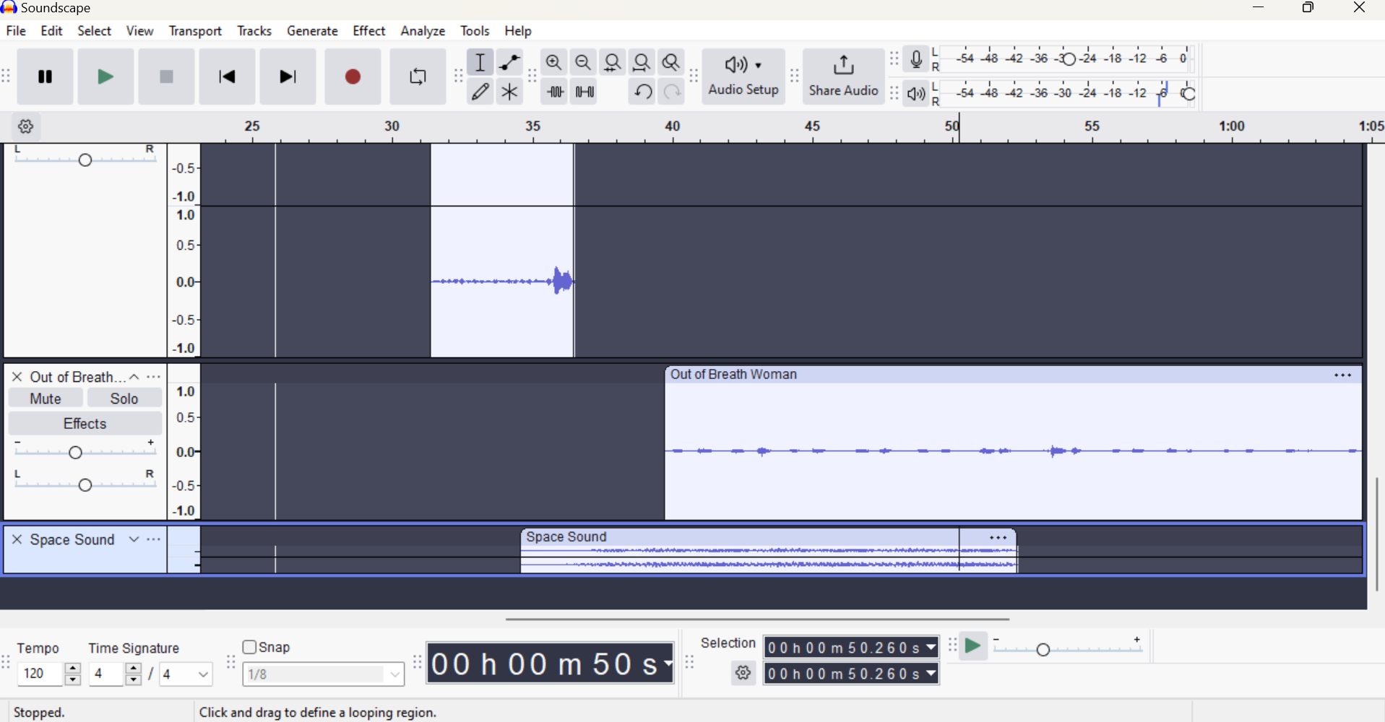

show that the person is witnessing something so heavenly and unearthly. I decided to finish the soundscape by fading everything out quickly because I wanted to end it letting the audience have their own view on it. I believe that even though it was difficult finding a bunch of familiar sounds that we have heard as humans to create this soundscape, I think I was able to create it with 3 parts and leave the audience feeling like they have experienced death and after death themselves. 